LED
Design Consideration

LED Application Note V1.0
© 2013-2021 Inolux Corporation

Introduction

This application note provides an overview of the Inolux LED Design Considerations for application design and engineering with binning and reliability assessments to refine the LED selection process.

Selection Criteria

In the design phase, LED selection may be critical to the esthetics and or functionality of an end product. The LED selection process gives designers the opportunity to understand what is needed to ensure ideal performance and minimal adjustments in the future.
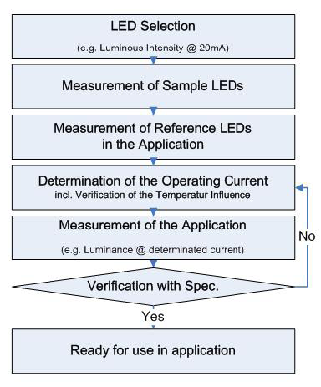
**Actual operation condition and function requirements allow selection criteria and technical specifications to be more easily defined.
The following are some of the key features to look for
  - Color
  - Brightness
  - Forward Voltage
  - View Angle
  - Component size, orientation, material
  - Circuit Functions
  - Secondary Optics
  - Temperature Range
  - Thermal Considerations

Color
Color selection would directly impact the esthetics of the end product. To ensure the accuracy and consistency of an end product, verification of the color requirements (wavelength and CIE coordinates) is advised.
When choosing the required color – bin selection is advised for applications requiring stricter uniformity. Based on color requirements, the bin range can be defined based on the human eye's discernability.
E.g., Human eyes can discern a yellow-green color easier than blue and red color, thus, the bin of yellow-green is set at a narrower wavelength range.
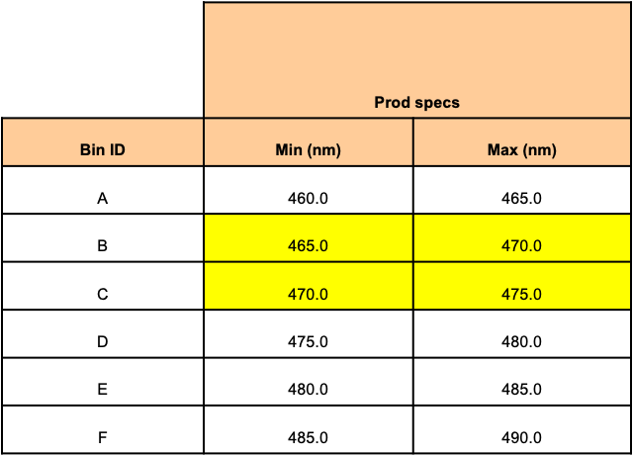
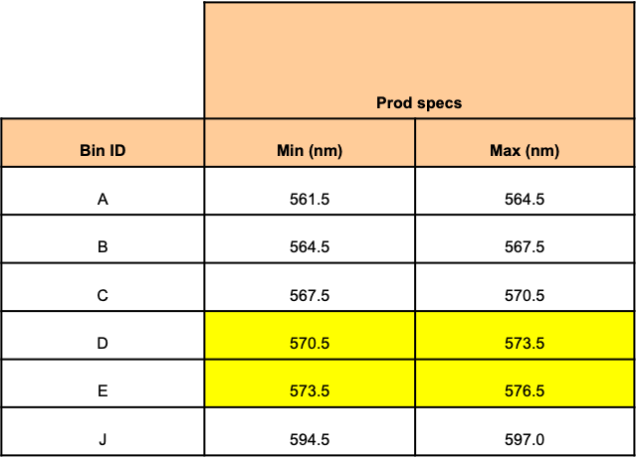

For White Color Selection, a specific CCT or a “Target” white color (Neutral, Cool, Warm) bin selection is advised to maintain consistency during assembly. For general illumination – 3-step / 5-step bin selection would help maintain color consistency when working in conjunction with an assembly line

Brightness
When considering the LED functions – brightness is often a key feature. Based on application, the following are generally some of the application requirements to consider.
a. Sunlight Readable: Higher brightness
b. Indicator Only: Only needs to light up
c. Indoor indication: moderate brightness
d. Dimmable / Adjustable: Has a current wide range
e. Color Mixing: In conjunction with other colors and achieve color mix by adjusting brightness
f. Uniformity: Consistency for either single system or multiple systems
Once “a” to “e” requirements have been defined, uniformity is often considered and LED intensity binning definition is required.

production specs (mcd) |  |  |  | production specs (mcd)
Bin ID | Min | Max |  | Bin ID | Min | Max |  | Bin ID | Min | Max
K | 7.15 | 11.25 |  | K1 | 7.15 | 9.00 |  | K2 | 9.00 | 11.25
L | 11.25 | 18.00 |  | L1 | 11.25 | 14.00 |  | L2 | 14.00 | 18.00
M | 18.00 | 28.50 |  | M1 | 18.00 | 22.50 |  | M2 | 22.50 | 28.50
N | 28.50 | 45.00 |  | N1 | 28.50 | 36.00 |  | N2 | 36.00 | 45.00
P | 45.00 | 71.50 |  | P1 | 45.00 | 56.00 |  | P2 | 56.00 | 71.50

*Human Eye Discernibility: Max to min ratio ≤2;
Each bin has max to min of 1.6; Each half-bin has max to min of 1.25

Forward Voltage
Forward voltage is the voltage drop of a diode at a given current and plays an important role when used in non-constant current designs with LEDs connected in a parallel circuit. In constant voltage drive and parallel conditions, the current through LEDs is only regulated by the voltage drop and resistors. Individual LED voltage drop differences would cause current hogging and thus result in brightness unevenness across the system. Therefore, choosing the correct Vf binning range and manage the assembly line correctly (use the same/similar bin range reel when assembling the same board) is crucial in maintaining a consistent brightness system.
2.45-2.55 | G1T |  | 2.85-2.95 | H1T
2.55-2.65 | G2T |  | 2.95-3.05 | H2T
2.65-2.75 | G3T |  | 3.05-3.15 | H3T
2.75-2.85 | G4T |  | 3.15-3.25 | H4T

View Angle
The view angle of the LED affects the directional light output. For the same chip, by narrowing the view angle, the light beam would be more focused with a higher intensity; by widening the view angle, the light would be more dispersed and thus dimmer. For designs requiring higher localized intensity, narrower view angles are advised. For designs needing more even light solutions, wider view angle LEDs are generally used.
1204 Red with 120 deg. | 1204 Red with 20 deg.
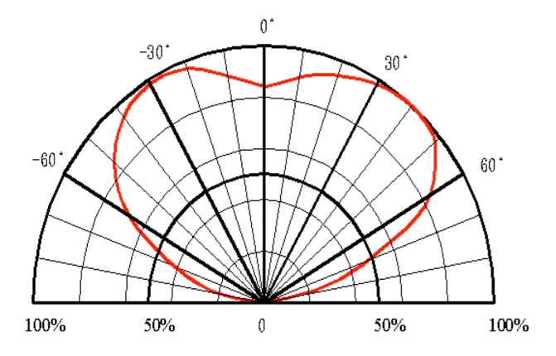 | 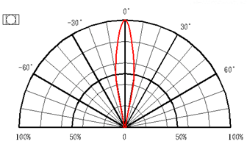
Typical Intensity: 112.5 mcd @20mA | Typical Intensity: 900 mcd @20mA

Components Size, Orientation, Material
The spacing and orientation of the LED can have a lasting effect on the design. Choose between top view, side view, or reverse mount type to accommodate the mechanical restrictions. The LED size and style (PCB, Lead frame, PLCC, Ceramic) would also affect the brightness and color yield.

Top view LEDs are most commonly used in designs with minimal mechanical constraints. Side view LEDs are most commonly used when perpendicular light direction is needed from the PCB. Reverse mount LEDs are generally used when there are tight mechanical constraints.

In general, larger LEDs can accommodate bigger chips, thus provide higher brightness, whereas smaller LEDs can squeeze in tight areas at the expense of die size.

From a material standpoint, PLCC-type LEDs can provide higher intensity due to their reflective cup design; ceramic-based LEDs can enable users to use higher driving power; FR4 / PCB type provides a cost-effective solution for general LED packages.

Circuit Functions
    - Current vs. Forward Voltage
LED’s brightness is a function of current. The brightness vs. current derating curve is close to linear. Thus, a current-controlled driving circuit is optimal for LED design. For voltage-controlled driving circuits, voltage drop calculations are needed to ensure uniformity. As LED forward voltage at a given current may be affected by temperature, this would also need to be taken into consideration. The following is an example of current calculation @ 25C.
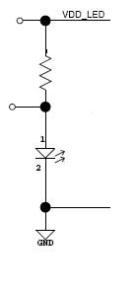
    - Application Condition
Both Brightness and Wavelength/CCT of LEDs are functions of current. Therefore, actual driving current in circuity would need to be considered when designing LED into applications to achieve brightness accuracy or correct color mixing.
*Actual forward current vs intensity condition/wavelength
    - Derating Curve Difference
Different chip/die types have varying derating curve functions. To ensure correct color/brightness is achieved based on the system circuitry design, verification of curve values is recommended.
e.g., RGB Systems:
*Iv-If curves different for red & blue/green
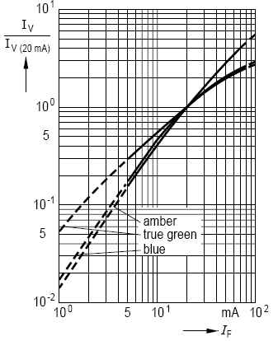
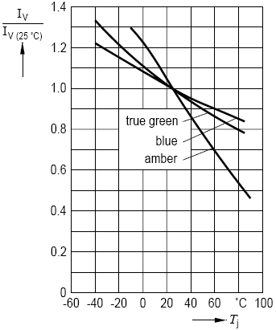
*Iv-Tj curves different for red & blue & green
*λd-If curves different for blue & green
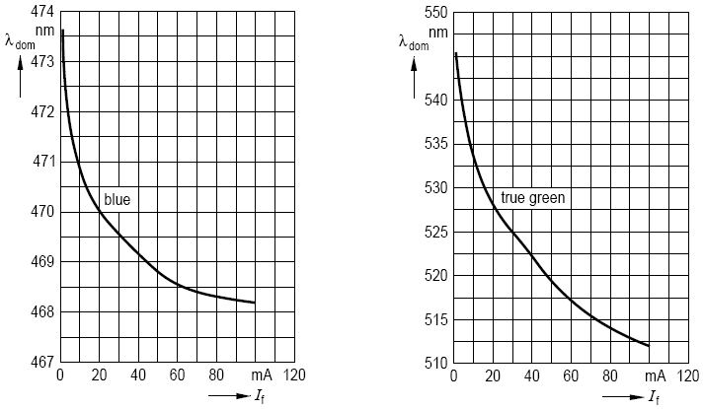

Secondary Optics
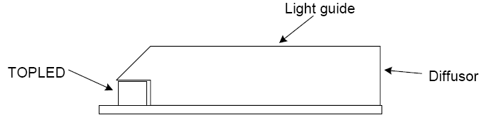
Particular designs may require secondary optics to guide light to specific areas. Depending on actual requirements, it is necessary to evaluate the orientation of the LED (top view/side view) or the brightness/color of the LED to achieve the desired effect. The secondary optics material would also have an impact on the uniformity and color shift of the LED.
*Light guide or light pipe material
a. Diffusivity, composition, tint
i. Higher diffusivity reduces brightness
ii. Material composition and tint changes color
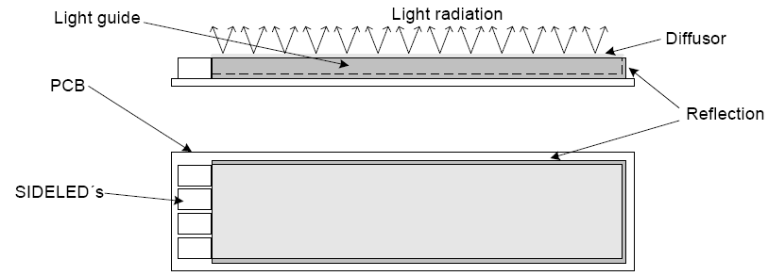
b. Geometry
i. Amplifies the above variables
Light guide or light pipe material can have varying diffusivity, composition, and tint which may change final color/brightness output.

Temperature Range
Temperature range would also affect LED forward voltage and brightness at a given current. Higher temperatures generally reduce the Vf and decrease brightness, whereas lower temperatures will typically increase the Vf and offer increased brightness.
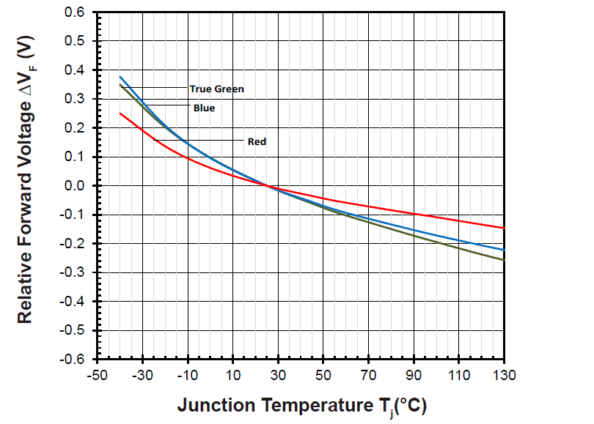

As a result, temperatures should be taken into consideration when designing LEDs into the circuitry to compensate for power consumption, brightness, and in very low-temperature cases, turn-on voltage conditions.

Thermal Consideration
The thermal design of the end product is important. The design of the thermal resistance between the junction and the solder point (R_{thJS}) and the thermal resistance between the solder point and ambient (R_{thSA}) should be minimized in order to optimize the emitter life and optical characteristics. The ultimate goal for the thermal design is not to exceed maximum junction temperature (T_{jmax}) during application.
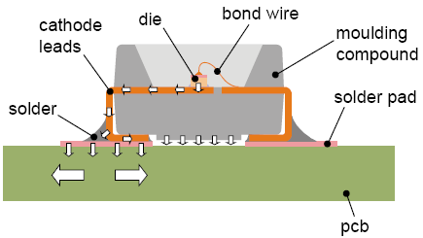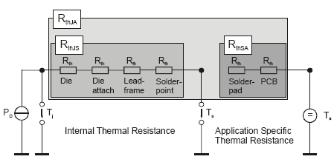
Example:
The junction temperature can be correlated to the thermal resistance between the junction and solder joint (R_{thJS}) and between the solder point and ambient ( R_{thJA}) by the following equation.
Tj = (R_{thJS}+R_{thSA}) x W+ Ta = = R_{thJA} x W + T_{a}
Typical R_{thJA} for small footprint SMD LED (pcb substrate) ~430ºC/W
Condition: If=5mA, Vf=2.9V
T_{j} = R_{thJA} x W + T_{a}
= (430degC/W) x (0.005A) x (2.9V) + 30ºC
= 36.2ºC
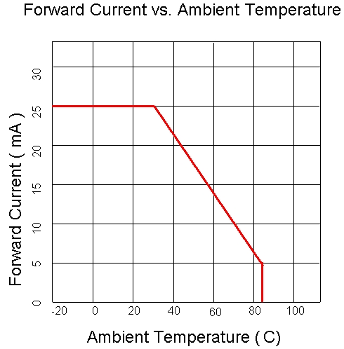
T_{j}: LED junction temperature
T_{a}: Ambient temperature
R_{thJA}: Thermal resistance between the junction and ambient
W: Input power (If *Vf )
The maximum operation current is generally determined by the T_{jmax} (Max junction temperature), for most SMD LEDs the Typical T_{jmax} = 95ºC
Based on the above, we can plot the curve of Allowable Forward Current vs. Ambient Temperature.

As the R_{thJS} will not change due to user design, the R_{thSA} should be considered if the product will be operating in extreme ambient temperature conditions. Airflow, substrate material, and heat sink should be considered when incorporating LEDs into the application design.

Quality
Inolux ensures the quality of its LEDs through reliability and lifetime tests according to JEDEC and other international standards. The reliability and life tests are an indication of the LED's performance and longevity in the real world. When designing the LEDs into a system, it is advised to consider these test results when evaluating the intended environment and usage conditions so that necessary measures can be put in place to ensure the effectiveness and longevity of the LED components.

3.1 Reliability

Item | Conditions
Precondition | 1.) Baking at 85°C for 24hrs  2.) Moisture storage at 85°C/ 60% R.H. for 168hrs
Solderability | Accelerated aging 155°C/ 24hrs  Tinning speed: 2.5+0.5cm/s  Tinning: A: 215°C/ 3+1s or B: 260°C/ 10+1s
Resistance to soldering heat | Dipping soldering terminal only  Soldering bath temperature  A: 260+/-5°C; 10+/-1s  B: 350+/-10°C; 3+/-0.5s
Operating life test | 1.) Precondition: 85°C baking for 24hrs  85°C/ 60%R.H. for 168hrs  2.) Tamb25°C; IF=20mA; duration 1000hrs
High humidity, high temperature bias | Tamb: 85°C  Humidity: 85% R.H., IF=5mA  Duration: 1000hrs
High temperature bias | Tamb: 55°C  IF=20mA  Duration: 1000hrs
Pulse life test | Tamb25°C, If=20mA,, Ip=100mA, Duty cycle=0.125 (tp=125μs,T=1sec)  Duration 500hrs)
Temperature cycle | A cycle: -40 degree C 15min; +85 degree C 15min  Thermal steady within 5 min..  300 cycles  2 chamber/ Air-to-air type
High humidity storage test | 60+3°C  90+5/-10% R.H. for 500hrs
High temperature storage test | 100+10°C for 500hrs
Low temperature storage test | -40+5°C for 500hrs

During the design and LED selection phase, the assembly, environment, and usage conditions of the system/application should be considered alongside the reliability robustness of the LED. If the required conditions exceed the scope of reliability testing, additional protection/shielding designs/protocols implementation is advised to avoid failures to the LEDs.

3.1 Life Test
Inolux performs product life tests on all its component series. With the exception of general lighting components, which require 6000hrs LM-80 testing, most LEDs receive the following 1000hrs life tests.
Operating life test | 1.) Precondition: 85°C baking for 24hrs  85°C/ 60%R.H. for 168hrs  2.) Tamb25°C; IF=(Operational Current)mA; duration 1000hrs

This provides an indication of the brightness intensity degradation over time. Utilizing projection/simulation formulas, we can estimate the L50 / L70 (50% intensity lifetime / 70% intensity lifetime) of the LEDs.

In general, higher temperatures and higher currents mean a shorter product lifetime; whereas LEDs with lower temperatures and lower currents commonly have a longer lifetime.

The following is the comparison of the same package under 20mA and 5mA @25C.
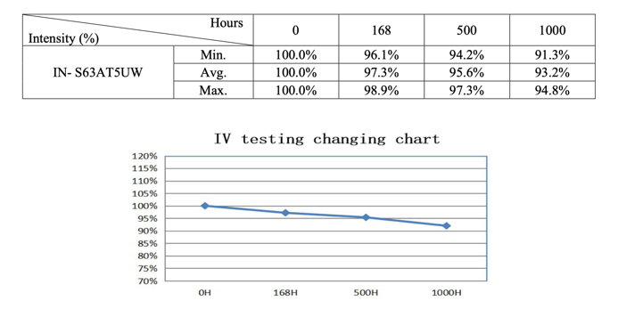
At 5mA the intensity remaining at 1000hrs is 93.2%
Based on MTBF Prediction, the L₅₀ life time is 35,753hrs.

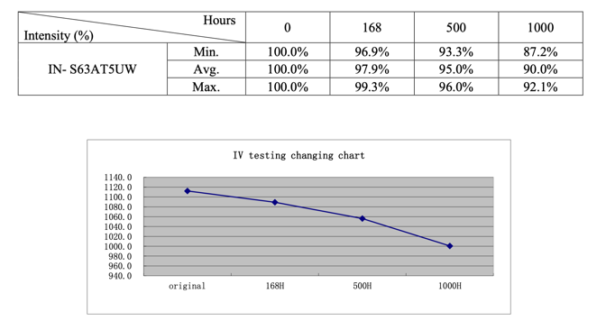
At 20mA the intensity remaining at 1000hrs is 90.0%
Based on MTBF Prediction, the L₅₀ life time is 10,583hrs

If the application current or temperature condition exceeds the conditions of the life test reports, a new life testing based on the required condition must be performed to obtain accurate life data.

